MICROSOFT 365 FOR STUDENTS

Dear student
Your institutional credentials that you received following your registration as an incoming mobility student give you free access to the Microsoft 365 platform, where you will be able to access, remotely or by downloading the appropriate apps, some fundamental tools to support your mobility, including which we mention:
• Microsoft Outlook, for managing your institutional email;
• Microsoft Word, Excel and Powerpoint for daily data management activities;
• Microsoft Teams, for managing audio/video connections remotely.
For correct management of the applications indicated above, we provide you with some simple instructions below.
- Access:
Access to Microsoft 365 takes place via the following hyperlink: https://www.office.com/ through the access credentials obtained upon successful completion of the enrollment procedure (username n.surname@studenti.unistrapg.it – personal password).

- App:
Once logged in, you can access the use of the Apps by selecting the required application directly by clicking on the appropriate icon: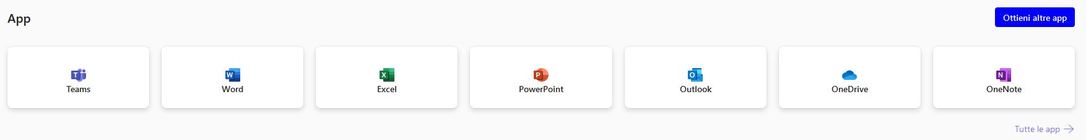

- email
For the entire duration of the mobility, any communication that the student will receive or send to the University for Foreigners must take place ONLY through the institutional email account (@studenti.unistrapg.it).
The Erasmus service staff often sends communications to international students regarding the management of mobility or initiatives promoted by the University, it is therefore recommended that all students regularly access their email inbox to check (and reply!) the communications received and manage your mobility correctly.

Thank you for your cooperation!

