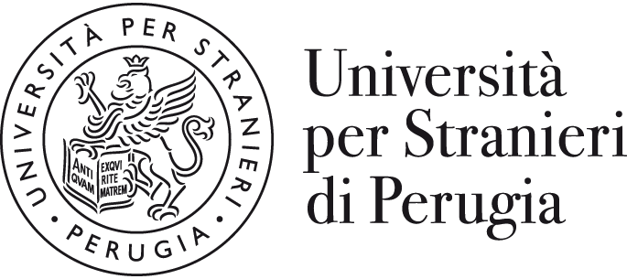 | INTERNATIONAL MOBILITY  Data Sheet “2024-25”
Name of University | Università per Stranieri di Perugia  University for Foreigners of Perugia
Erasmus code | I PERUGIA 06
Website | www.unistrapg.it
Address | Piazza Fortebraccio 4 – 06123 Perugia (ITALY)
Departments | Dipartimento di Scienze Umane e Sociali Internazionali  Dipartimento di Lingua, Letteratura e Arti italiane nel mondo
Head of Institution | Prof. Valerio de Cesaris (Rector)  E-mail: rettore@unistrapg.it
International mobility Institutional Coordinator | Prof.ssa Federica GUAZZINI  E-mail: federica.guazzini@unistrapg.it
Head of International relations, Erasmus and Mobility office | Mr Francesco LAMPONE  E-mail: erasmus@unistrapg.it

ERASMUS AND INTERNATIONAL MOBILITY OFFICE: CONTACTS
General e-mail address for enquiries | erasmus@unistrapg.it
Exchange agreements | Mr Filippo CAPRUZZI  Tel: +39 (0)75 5746266  E-mail: erasmus@unistrapg.it
incoming students advisor | Mr Filippo CAPRUZZI  Tel: +39 (0)75 5746266  E-mail: erasmus@unistrapg.it
outgoing students advisor | Mr Paolo FEI  Tel: +39 (0)75 5746301  E-mail: erasmus@unistrapg.it
Staff mobility (teaching/training) | Mr Paolo FEI/ Mr Filippo CAPRUZZI  Tel: +39 (0)75 5746301/266  E-mail: erasmus@unistrapg.it
Website for international students | https://www.unistrapg.it/it/area-internazionale/studenti-internazionali/mobilita-extra-erasmus-incoming-students

DEGREE COURSES
Academic Calendar (Degree Courses) | Autumn semester: beginning of October to end of December  Spring semester: beginning March to end of May
Examination Periods (Degree Courses) | Autumn semester: January/February  Spring semester: June/July
Recommended arrival dates  (probable dates) | Autumn semester: Last week of September  Spring semester: Last week of February
Language of courses | Italian
Courses taught in English | Yes
Average credit load per course (ECTS) | 3 or 6 or 9

EXCHANGE RELATED INFORMATION
Nomination deadlines | Autumn semester: 30 June  Spring semester: 31 January
Application deadlines | Autumn semester: 31 July  Spring semester: 30 November
Application for international students | Electronic Paper-based
Website for exchange application information | https://www.unistrapg.it/it/area-internazionale/studenti-internazionali/mobilita-extra-erasmus-incoming-students
Online application for ordinary courses in Italian language and culture (in presence) | https://www.unistrapg.it/node/4055
Online application for distance courses in Italian language | https://www.unistrapg.it/en/node/6912
Contact Person for application information  Tel./ E-mail | Name: Mr Filippo CAPRUZZI  Tel: +39 (0)75 5746266  E-mail: erasmus@unistrapg.it

DEGREE AND MASTER DEGREE COURSES ON OFFER
First level degree courses | Comunicazione internazionale e pubblicitaria (ComIP)
 | Lingua e cultura italiana nel mondo digitale (LiCIMoD)
 | Made in Italy, cibo e ospitalità (MICO)
 | Scienze sociali per la sostenibilità e la cooperazione internazionale (SoCI)
Second level degree courses | Comunicazione pubblicitaria, storytelling e cultura d'immagine (ComPSI)
 | Italiano per l'insegnamento a stranieri (ItaS)
 | Relazioni internazionali e cooperazione allo sviluppo (RICS)

Language of instruction
All the courses offered within the first and second level degrees are taught in Italian language.
The minimum level recommended for incoming students to attend classes of Degree courses is B1/B2.

Students with a poor knowledge of the Italian laguage (A1 and A2) are strongly invited to attend courses in Italian language and Culture and improve their linguistic abilities before starting to attend degree and master degree courses

COURSES IN ITALIAN LANGUAGE AND CULTURE FOR FOREIGNERS
Academic Calendar | Courses are available all the year, the official schedule is available at: https://www.unistrapg.it/en/studying-unistrapg/italian-language-and-culture-courses
Examination Periods  (Language courses) | March, June, September and December  (at the end of three-months ordinary courses)
Average credit load per course (ECTS) | Monthly courses: 6 ECTS (levels A1-B2)  Monthly courses: 8 ECTS (levels C1-C2)  Three-months courses (level A1 to B2): 20 credits  Three-months courses (level C to C2): 30 credits
Cost | Free of charge for exchange students

HOUSING RELATED INFORMATION
Accommodation | Off-Campus
Cerc@lloggio umbria | https://www.unistrapg.it/en/campus-life/services/cerclloggio-umbria

APPROXIMATE COSTS
Student insurance  (to be purchased in Italy for Permit of Stay purpose) | From 1 to 6 months stay: 49 Euro  From 1 to 6 months stay: 98 Euro
Accommodation (Dormitory – if available) | Around 250 euro per month
Accommodation (Homestay) | Around 300 euro per month
Study material | Around 100 euro per month
Food | One complete meal at the University canteen: 5,00 euro
City transportation | One-hour urban city bus: 1,50 euro

IMPORTANT:
All incoming exchange students from non-UE countries must be in possess of the Visa for Study purpose to be accepted.

