### logo senza scritta.gif

### ERASMUS STUDENT EXCHANGE PROGRAMME

### Data Sheet Academic Year 2017-2018

|  |  |
| --- | --- |
| Name of University | Università per Stranieri di Perugia |
| Erasmus code | I PERUGIA 06 |
| Website | www.unistrapg.it |
| Address | Piazza Fortebraccio 4 – 06123 Perugia ITALY |
| Tel/Fax/E-mail | +39 075 57461 erasmus@unistrapg.it |
| Head of Institution | Mr Giovanni PACIULLO (Rector) |
| Erasmus Departmental Coordinator | Prof. Federica GUAZZINIEmail: Federica.guazzini@unistrapg.it |
| Head of the International Relations, Erasmus and mobility office | Mr Fabrizio FOCOLARIEmail: erasmus@unistrapg.it |
| Incoming students advisors | Mr Filippo CAPRUZZI Email: erasmus@unistrapg.it – Filippo.capruzzi@unistrapg.itMr Paolo FEIEmail: erasmus@unistrapg.it – paolo.fei@unistrapg.it |

### C:\Users\filippo.capruzzi\AppData\Local\Microsoft\Windows\Temporary Internet Files\Content.IE5\8RN3D3WA\MC900342941[1].wmf

### Contacts:

|  |  |
| --- | --- |
| Erasmus and mobility programs - Contacts | |
| Address | Palazzo Gallenga - 1st floorPiazza Fortebraccio, 4 – Perugia |
| For incoming students | Mr Filippo CapruzziTel: +39 (0)75 5746266 - 301E-mail: [erasmus@unistrapg.it](mailto:erasmus@unistrapg.it) – filippo.capruzzi@unistrapg.it |
| Website for incoming students | https://www.unistrapg.it/it/area-internazionale/studenti-internazionali/erasmus-incoming |

### C:\Users\filippo.capruzzi\AppData\Local\Microsoft\Windows\Temporary Internet Files\Content.IE5\8RN3D3WA\MC900232899[1].wmf

### Arrival and official enrolment

### Before getting to Perugia Erasmus incoming students should arrange a meeting with the Erasmus advisor of the University for Foreigners Perugia in order to start the enrolment procedures.

### At the moment of the registration every student will be provided with the following documents:

### Confirmation of arrival form;

### Certificate of acceptance as Erasmus student;

### Welcome folder kit;

### Directions on Degree courses (and the relevant booklet) and ordinary courses in Italian Language and Culture.

### Entrance Test

### Every incoming student is requested to take part in the *entrance test* in order to evaluate the level of Italian language competence. At the end of the test the student will receive the official schedule of the course in Italian language and culture for his level and the official student card.

### Attendance of the courses

### Students are invited to attend the classes of the subjects indicated in their learning agreements according to the official academic calendar. The timetable of the classes is published on the website of the University:

### https://www.unistrapg.it/node/87

### There’s not an official procedure of registration, students just have to introduce themselves to the teachers during the first lessons and they will provide every useful information on the course, the relevant didactic programme and the final exam.

### Learning agreement and changes to the original learning agreement

### Incoming students are invited to check the availability of the subjects indicated in their learning agreements signed before the start of the Erasmus mobility as soon as the official schedule of the courses is published on the website: https://www.unistrapg.it/node/87

### Once classes start, there is one-month time to propose any possible change to the original learning agreement; students must provide the Erasmus advisor of the University for Foreigners Perugia with his changes form and the contacts of the Erasmus coordinator of the Home university where the document will be emailed or posted for the official approval.

### Prolongation

### Students willing to prolong their Erasmus mobility must fill in a specific form of request using the relevant paper available at the Erasmus office. The prolongation request must be duly motivated by academic reasons and it must be produced *one month before the end of the mobility* originally planned to the Erasmus advisor of the University for Foreigners Perugia.

### The official request of prolongation must be officially signed as approval by the Erasmus coordinator of the Home University and later by the Erasmus coordinator of the Host University.

### End of the Erasmus mobility

### Students are to inform the Erasmus staff about their departure at least 10 days before the beginning of the mobility period.

### At the end of the study period student must provide the Erasmus advisor of the Host University with the personal “*Erasmus Studies Leaflet*” and every certificate related to the attendance of the ordinary courses in Italian language and culture.

### Before leaving Perugia students must arrange a meeting with the Erasmus advisor of the University for Foreigners Perugia in order to check the availability and accuracy of all the documents related to the Erasmus mobility.

### Upon the last meeting incoming students are provided with:

### Official certificate of attendance stating the dates of the Erasmus mobility;

### Original learning agreement and changes form duly signed and stamped.

### Transcript of Records

### The official Transcript of Records will include and the activities regularly certified, the final marks of the exams and the relevant ECTS credits. The document will be posted to the attention of the Erasmus coordinator of the Home University in a few days after the end of the Erasmus mobility.

### C:\Users\filippo.capruzzi\AppData\Local\Microsoft\Windows\Temporary Internet Files\Content.IE5\XAMM19KL\MC900233972[1].wmf

### Courses on offer

Erasmus incoming students at the University for Foreigners Perugia are offered the opportunity to attend all the courses activated in the following areas:

* Degree courses
* [Courses in Italian Language and Culture](http://www.unistrapg.it/en/prospectus/italian-language-and-culture-courses)

The overall list of the subjects available in each semester is published a few days before the beginning of the academic semester.

Students are advised to check the availability of the subjects indicated in their learning agreement immediately after their arrival in Perugia and fill in the “changes to the learning agreement” within 30 days by the Erasmus starting date.

### IMPORTANT:

### All Eramus incoming students will be enrolled in the ordinary courses in Italian language and culture (independently from their attendance of these courses); it is absolutely necessary to maintain the validity of the enrolment as students of the language courses throughout the entire mobility period in order to maintain the status of erasmus student.

### Language requirements

### Courses are taught in Italian (only a limited number of subjects will be offered in English).

PLEASE NOTE:

Students with a poor knowledge of the Italian language (A1 and A2) are invited to attend courses in Italian language and Culture. The minimum level recommended for incoming student to attend classes of Degree courses is **B1** (CEFR).

### Degree courses Academic calendar 2018/19

Fall term (1st six month period):  
 from 1 October to 21 December 2018

Spring term (2nd six month period):  
 from 4 March to 31 May 2018

### Degree courses Exam period

Fall term (“primo semestre): January – February 2019

Spring term (“secondo semestre”): June – July 2019

### C:\Users\filippo.capruzzi\AppData\Local\Microsoft\Windows\Temporary Internet Files\Content.IE5\8RN3D3WA\MC900335274[1].wmf How to go about…Degree courses

### Upon arrival

### Incoming Erasmus students have to check personally the availability of the courses indicated in the learning agreement submitted before the arrival in Perugia.

### The schedule is published a few days before the official beginning of the classes at the following link: https://www.unistrapg.it/node/87

### After the official beginning of the classes incoming Erasmus student have one-month time to indicate possible changes in the original learning agreement using the relevant form “*changes to the original learning agreement*” (this paper must be signed and approved from both Home and Host Universities).

### During the courses

### Incoming Erasmus students are invited to introduce themselves to the teacher of each class, he will provide all relevant details on the course (methods of teaching, possible assignments and the date of the final exam).

### At the end of the course

### It is absolutely necessary for all incoming students to complete the personal registration for the final exam of each subject (at least two weeks before the official date of the exam); for this purpose, every student need to provide his teacher with the paper “*Iscrizione prova finale*” that can be collected by student at the Erasmus office.

### iscrizione esame laurea.jpg*(“iscrizione prova finale”)*

### The day of the final exam Erasmus students must provide the teacher with the “*Libretto per la certificazione dei titoli acquisiti*”; every teacher teacher must sign it and fill in indicating the final mark and the ECTS awarded by the course.

### At the end of all the exams Erasmus students have to hand in the “*Libretto per la certificazione dei titoli acquisiti*” (duly signed and filled in by the teacher) to the personnel of the Erasmus office of the University for Foreigners Perugia.

### The “Erasmus Studies Leaflet” (Libretto per la certificazione dei titoli acquisiti)

Upon registration in the Erasmus office, each student will be given a booklet for registration of activities and exams carried out in this Athenaeum; it must be handed back at the moment of leaving the University in order to receive the final certificate.

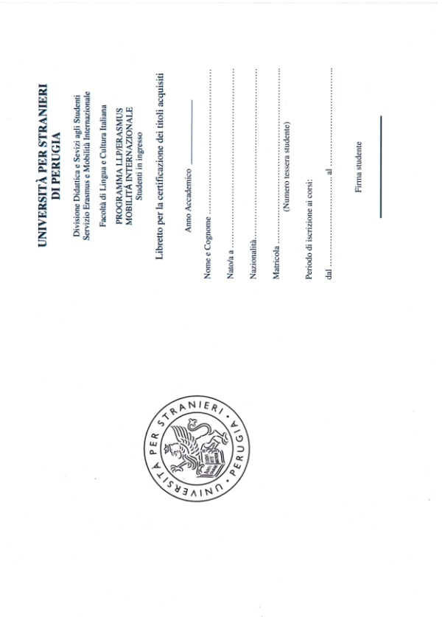*(“libretto certificazione titoli acquisiti”)*

It will be the student’s responsibility, when taking exams, to show the booklet to the teacher to be signed and the marks registered. The booklet must be kept in a safe place for the entire duration of the stay, as the exams taken and credits achieved will be needed to complete the final Transcript of Records.

### Please note:

### the final Transcript of Records will include all the subjects attended and the ECTS acquired, provided that they are regularly registered in your “*Libretto per la certificazione dei titoli acquisiti*”, students have to check that teachers have regularly signed the Libretto and included their signature and your final mark before handing in the paper to the Erasmus officers.

**Courses and programs**

The detailed programs of the subjects activated in the Degree course can be found at the following links:

Comunicazione internazionale e pubblicitaria (COMIIP)

https://www.unistrapg.it/node/42  
  
Lingua e cultura italiana (LiCi)

https://www.unistrapg.it/node/346

Comunicazione pubblicitaria, Storytelling e cultura d’immagine (ComPSI)

https://www.unistrapg.it/node/349

Relazioni internazionali e cooperazione allo sviluppo (RICS)

https://www.unistrapg.it/node/350

Italiano per l'insegnamento a stranieri (ItaS)

https://www.unistrapg.it/node/351

Promozione dell'Italia e del Made in Italy (PrIMI)

<https://www.unistrapg.it/node/352>

Traduzione e Interpretariato per l’internazionalizzazione dell’impresa

https://www.unistrapg.it/node/3024

**Teachers**

Teachers contacts and their weekly receiving schedule are available on the University webpages at: https://www.unistrapg.it/it/studying-unistrapg/degree-courses/informazioni-corsi-di-laurea-0

### C:\Users\filippo.capruzzi\AppData\Local\Microsoft\Windows\Temporary Internet Files\Content.IE5\XAMM19KL\MM900178261[1].gifHow to go about…ordinary courses in Italian Language and Culture

**At the beginning of the course** Erasmus incoming students have to:

1. Sit the Entrance Test;
2. Inform the Erasmus advisor of the Erasmus office on the level of the course assigned (level and code) and provide the officers with a copy of the classes’ schedule;
3. Provide the teacher of “Lingua Italiana” of the course with the official letter of presentation (**Form “A”)** given by the Erasmus and International Mobility office;

**At the end of the course**:

1. The day of the final exam Erasmus students have to provide the teacher of “Lingua Italiana” with the **Form “B”**, that the teacher must fill in and sign at the end of the test with your final mark;
2. Hand in the FORM “B” (duly signed and filled in by the teacher) to the personnel of the Erasmus advisor of the Erasmus office.

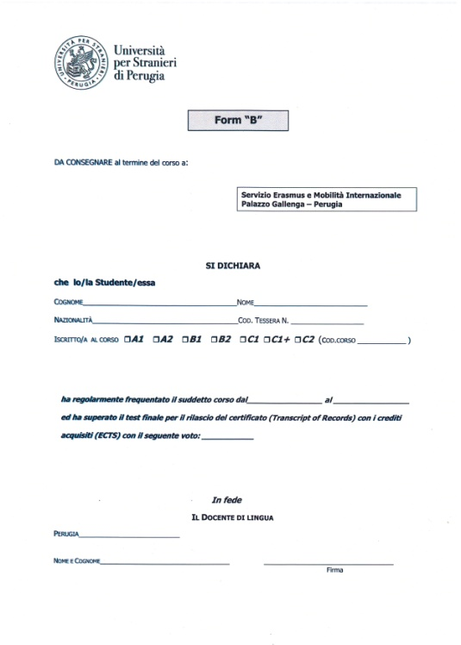*(Form “B”)*

**PLEASE NOTE:**

In order to be awarded the ECTS credits, all the exchange students taking part in the courses of Italian Language and Culture need to **sit a final test** at the end of the course. The final mark is extremely important because it is part of the “Transcript of Records and it is absolutely necessary for the academic recognition of the course at the end of your period of study.

Students who do not need ECTS credits for the courses in Italian language are invited to join the courses in order to improve their linguistics competencies.

**ECTS AWARDED UPON SUCCESSFUL COMPLETION OF THE LANGUAGE COURSES:**

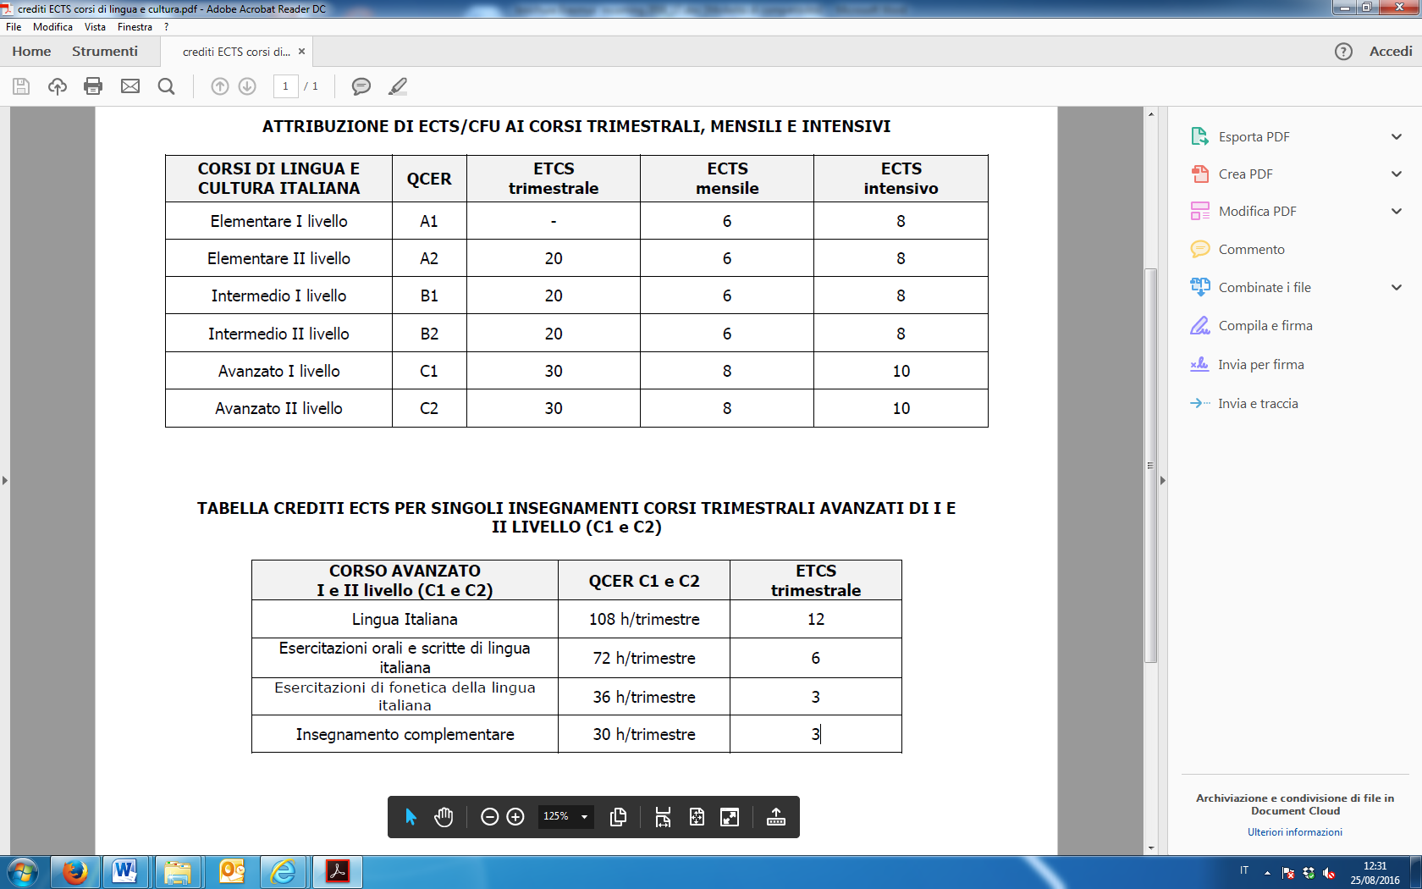

All relevant information on the ordinary courses in Italian language and culture for foreigners are available on our webpages: https://www.unistrapg.it/it/node/30

**Useful information**

**C:\Program Files (x86)\Microsoft Office\MEDIA\CAGCAT10\j0293236.wmf**

**Canteen Card Adisu (Tessera mensa Adisu)**

Erasmus incoming students must apply for a card which allows them to use the self-service University canteens cared by the Adisu (Agency for the Right to Study).

In order to apply for the card students must provide Adisu officers with the official certificate of acceptance as Erasmus student released by the personnel of the Erasmus office upon the arrival in Perugia.

Adisu:

Via Benedetta 14, Perugia

Tel. 075 4693000

Fax 075 5847107

The office (*servizio mensa*) is open according to the following timetable:

Monday: 9.00 to 13.00  
Tuesday: 15.00 to 17.30  
Wednesday: 9.00 to 13.00  
Thursday: 15.00 to 17.30  
Friday: CLOSED

Canteens are open from Monday to Saturday , from 12,00 a.m. to 2,30 p.m. and from 7,00 p.m. to 9,00 p.m.); the average price for a complete lunch is around 4,50 Euro. The cost of the card is 2 Euro.

The Canteen in via XIV Settembre (close to Palazzina Lupattelli)

Via XVI Settembre

Opening hours between Monday and Friday: 12:00 - 14:00

Tel. 075 4693204

The Canteen in Via Pascoli (close to Palazzo Gallenga)

Via Pascoli, n° 23/25

Opening hours between Monday and Saturday

12:00 - 14:00 and 19:00 - 21:00

Tel. 075 43670

**WiFi**

Students are offered the possibility to use for free the wifi connection to the Internet in the areas of the University campus using a username and a password awarded by the computer services office of the University.

Username and password are provided according to the following schedule:

“Centro Elaborazione Dati” office – Palazzo Gallenga (4th floor)

Monday: 9:00 – 11:00

Wednesday: 11:00 - 13:00

Friday: 10:00 – 12:00

Palazzo Gallenga (Aula Magna, sala Goldoniana, saletta del vecchio caffè, bar);

University Campus: Palazzina Valitutti - Classrooms A and B and area outside the building;

Palazzina Prosciutti: internal bar and area outside the building.

### Published by:

### International Relations, Erasmus and Mobility office

### Tel: +39 075 5746266 – 301 - 303

### Erasmus@unistrapg.it