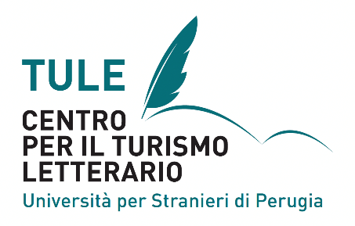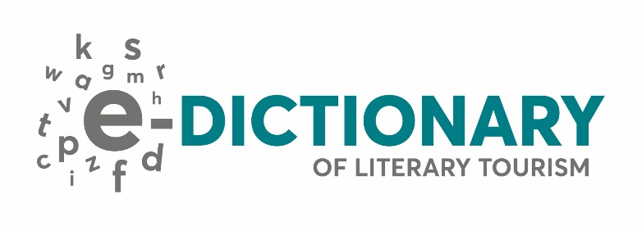

E-DICTIONARY OF LITERARY TOURISM
2nd CALL FOR DICTIONARY ENTRIES

The Research Centre for Literary Tourism (TULE), based at the University for Foreigners of Perugia (Italy), opens a second call for proposals for dictionary entries to be included in the E-Dictionary of Literary Tourism.
This dictionary aggregates texts on concepts, authors, places, products and experiences associated with literary touring. It is available online for all who wish to learn about this expanding tourism niche.
All submissions go through a double-blind review process.
Check the entries that have already been published and submit a 100-word-topic proposal in English to tule.literarytourismresearch@gmail.com by 15 April 2024.
After the proposal acceptance, TULE will invite the submission of the complete dictionary entry (1500 words) by 31 July 2023.

Guidelines for the 1500-word dictionary entry:

Font: Candara
Size of font: 12pt (text and references) and 13pt – the title
Line spacing: 1,15
Number of references: up to 5
Voice: impersonal (not “I” nor “we”)
Quotation marks: “…”
Quotation marks inside quotation marks: «…»
It should be a full text with no subsections (unless they are very pertinent)
Margins: top and bottom: 2,5 cm; left and right: 3 cm
All images should be labelled “Figures”, and they should be numbered. The title of the figure should be in font 10pt, and the source must be included unless it is by the author of the entry.
References APA 7th edition.

